GOOGLE CLOUD LAB
1. Execute a Python Program in Google Cloud Shell
Aim: Run a Python application using a cloud-based environment.
Steps:
- Open Google Cloud Console.
- Login with Gmail.
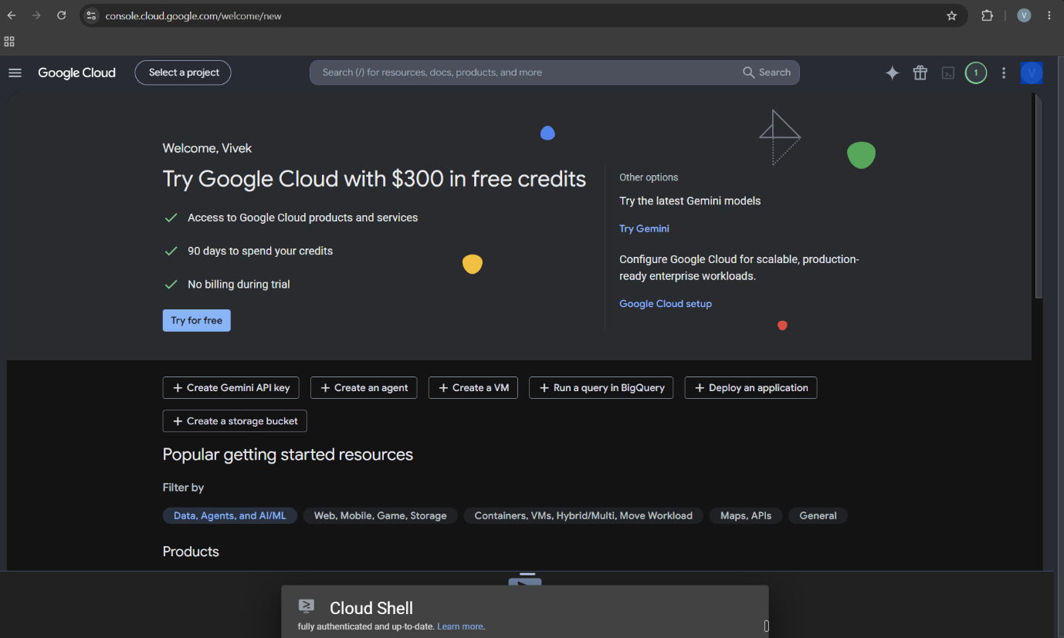

- Click Activate Cloud Shell (>_) at the top.
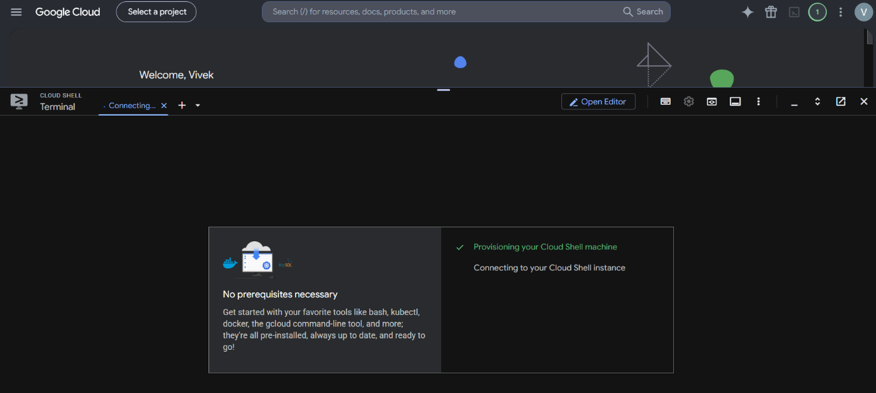
- Type:
nano hello.py
- Enter:
print("Hello from Google Cloud!")
print("Welcome to Cloud Computing")
- Save: Ctrl+O → Enter → Ctrl+X
- Run:
python3 hello.py
Output:
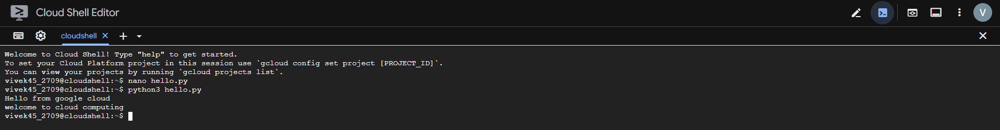
Hello from Google Cloud!
Welcome to Cloud Computing

2. Create and Manage Files in Cloud Storage of Cloud Shell
Aim: Demonstrate cloud-based file creation and management.
In Cloud Shell:
mkdir cloudlab
cd cloudlab
echo "Welcome to Google Cloud" > sample.txt
cat sample.txt
Check files:
ls
Copy the file:
cp sample.txt backup.txt
Then:
Ls

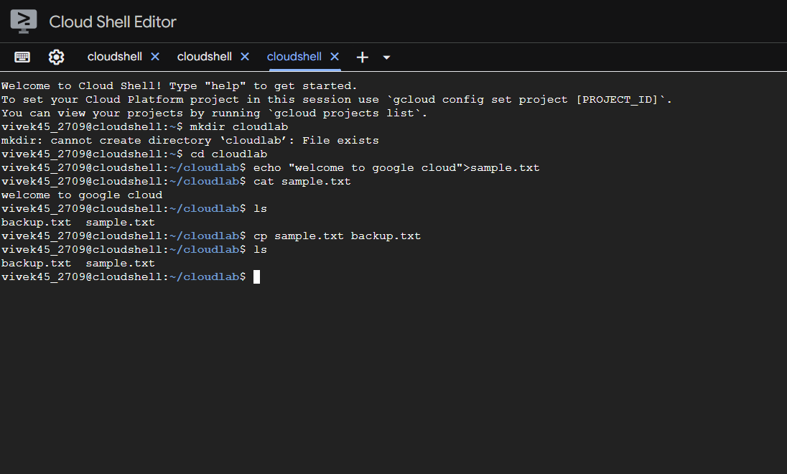

3. Run a Simple Web Server in Google Cloud Shell
Aim: Host and access a simple webpage from a cloud development environment.
Create HTML:
nano index.html
Enter:
<html>
<body>
<h1>Google Cloud Practical</h1>
<p>My first cloud web application</p>
</body>
</html>
Save and execute:
python3 -m http.server 8080
Then click Web Preview → Preview on port 8080 in Cloud Shell.
The webpage opens in the browser.
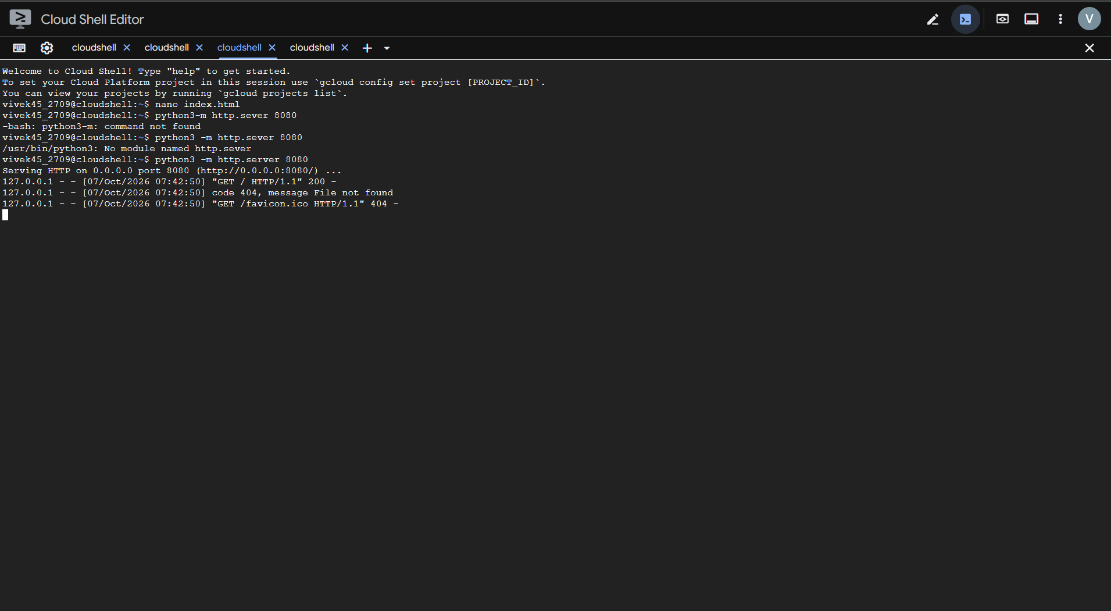
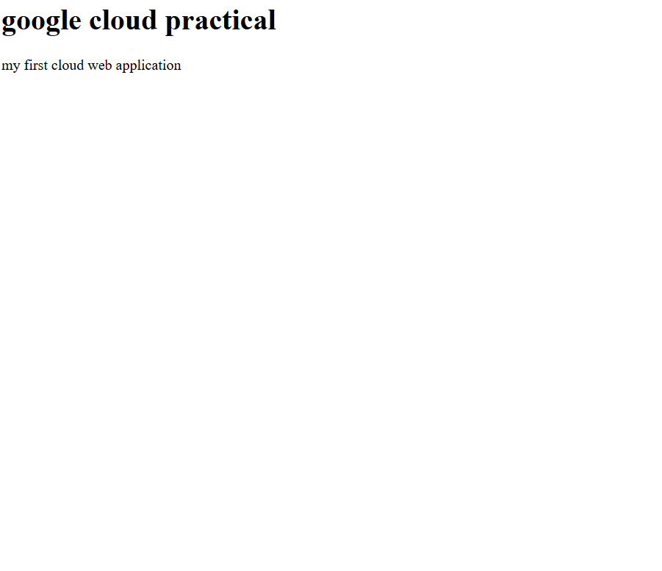

4. System Resource Monitoring in Google Cloud Shell
Aim: Demonstrate monitoring of CPU, memory and storage resources in a cloud environment.
Open Cloud Shell and execute:
free -h
Shows RAM usage.
df -h
Shows storage/disk usage.
lscpu
Shows CPU information.
Finally:
top
Shows running processes and CPU/memory utilization.
Press q to exit.
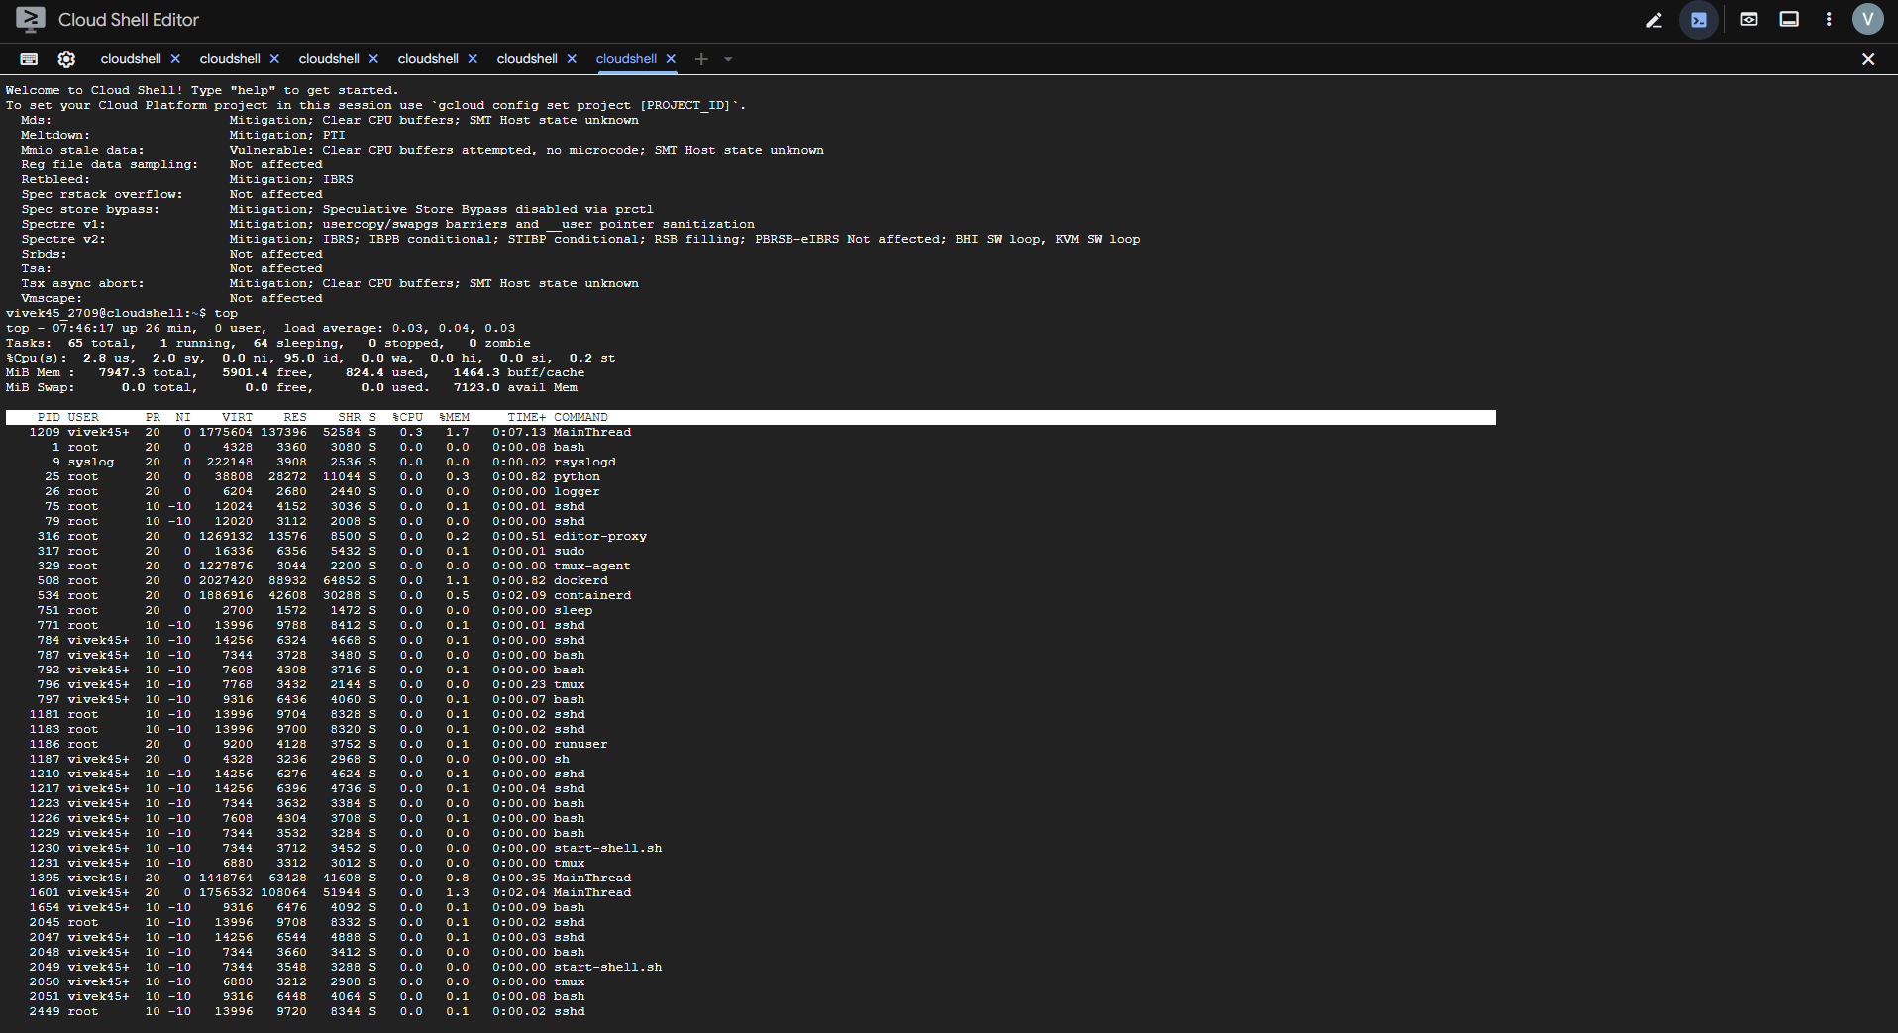

5. Execute a C Program in Google Cloud Shell
Aim: Compile and execute a C application in a cloud-based environment.
Create program:
nano add.c
Enter:
#include <stdio.h>

int main()
{
int a = 10, b = 20;
printf("Sum = %d\n", a + b);
return 0;
}
Compile:
gcc add.c -o add
Run:
./add
Output:
Sum = 30
